October 2019 AA Newsletter
10th Step: “Continued to take personal inventory and when we were wrong promptly admitted it.”
10th Step Prayer: “God remove the Selfishness, dishonesty, resentment and fear that has cropped up in my life right now. Help me to discuss this with someone immediately and make amends quickly if I have harmed anyone. Help me to cease fight anything and anyone. Show me where I may be helpful to someone else.”
10th Tradition: Alcoholics Anonymous has no opinion on outside issues; hence the A.A. name ought never be drawn into public controversy. ... It does not engage in any controversy, neither endorses nor opposes any cause.
10th Concept: We are of service by accepting responsibility for the authority God has given us and by respecting the authority God has given to others.

BIRTHDAYS
Mossy Head :
Debbie G. 10/09/2002 17 yrs
Traditions Workshop January 18, 2020
10am to 2pm
Journey Pure Treatment Center
348 Miracle Stip Parkway SW
FWB 32548
In the back parking lot near IHOP

On Awakening:
Paul S. 10/04/2017 2 yrs
Todd W. 10/01/1986 33 yrs
Jess P. 10/18/2017 2yrs
Abby B. 10/04/2016 3 yrs
Erin P. 10/08/2018 1 yr
Ron B. 10/15/2018 1 yr
Bill G 10/26/2018 1 yr
AA Funnies:
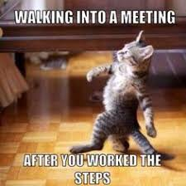
10th Step Inventory Checklist (I thought this would be cool to include)
https://www.google.com/url?sa=i&rct=j&q=&esrc=s&source=images&cd=&cad=rja&uact=8&ved=2ahUKEwiOrf-l_o3lAhVJM6wKHed2Bf8Qjhx6BAgBEAI&url=https%3A%2F%2Fissuu.com%2Fsponsor_magazine%2Fdocs%2F10_inventory&psig=AOvVaw2ur2CswGBE0gfX1nFGkZLV&ust=1570669535818438
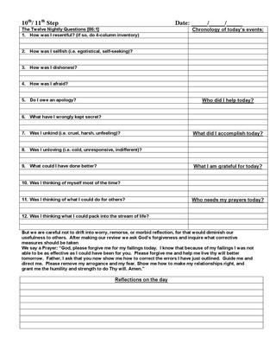
Editor Amanda B.
Email to submit articles etc. infoandnews@centurylink.net

