May 2020 AA Newsletter:

Step 6: Were entirely ready to have God remove all these defects of character.
Tradition 6: An A.A. group ought never endorse, finance, or lend the A.A. name to any related facility or outside enterprise, lest problems of money, property, and prestige divert us from our primary purpose.
Concept 6: “The Conference recognizes that the chief initiative and active responsibility in most world service matters should be exercised by the trustee members of the Conference acting as the General Service Board.”
6th Step Prayer: “God help me become willing to let go of all the things to which I still cling. Help me to be ready to let You remove all of these defects, that Your will and purpose may take their place.”
June Birthdays:

No birthdays have been submitted this month but we are sending a special *CONGRATS* to anyone celebrating an anniversary!

Upcoming Events:
** 2020 AA International Convention in Detroit has been cancelled
Area One Convention
“Love & Service”
Sept 11-13th, 2020
Location: Orange Beach Event Center

4672 Wharf Pkwy Orange Beach, Alabama

**Individuals should consider donating direct to Intergroup which still maintains the office and phone. You can do so here at: fortwaltonbeachaa.org

LOCAL Zoom Meeting List:
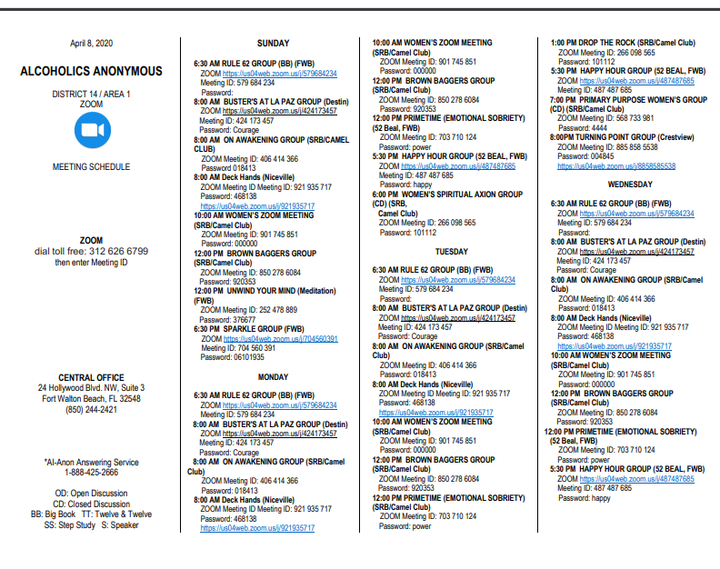

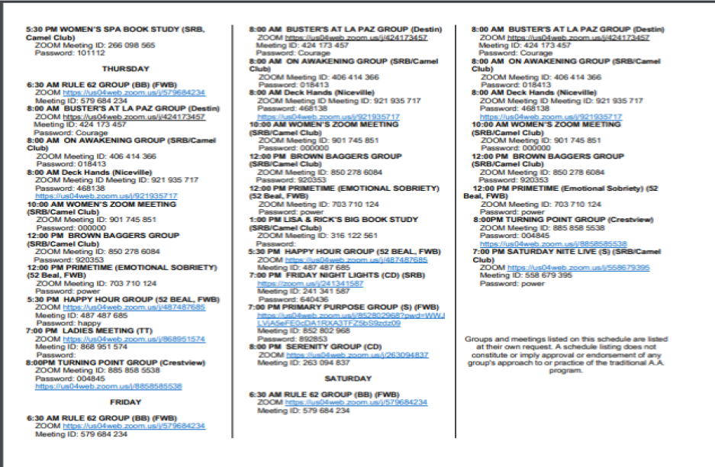

Worried About Staying in Recovery During COVID-19? You’re Not Alone
By CARRIE MACMILLANAPRIL 16, 2020

Yale Medicine specialists discuss risk factors for people with alcohol and substance use disorders.
"Our strides are at risk and we may start to see more opioid-related overdoses and infections from injections," says David Fiellin, MD, director of the Yale Program in Addiction Medicine, speaking of the COVID-19 pandemic.

Social distancing is a public health measure to help curb the spread of COVID-19, but it presents unique challenges to people with alcohol or other substance use disorders.

In treatment and recovery, people rely on the support of in-person groups (including Alcoholics Anonymous and Narcotics Anonymous) or may need to visit a clinic that dispenses medication, such as methadone, daily or several times a week.

Also, it’s often true that even beyond the supportive face-to-face interactions, the structure of a daily routine is important in preventing relapse, says David Fiellin, MD, director of the Yale Program in Addiction Medicine.

“Many are now facing changes in their work schedules, childcare, and family responsibilities. They may also have increased idle time,” he says. “All of that, in addition to the stress and anxiety people may be feeling right now, and their potential isolation, can be threats to individuals with substance and alcohol use disorders.”

Stress motivates people to access their coping strategies, Dr. Fiellin explains. “Unfortunately, for those who are early in treatment or still intermittently using, a common coping strategy is substance use,” he says.

Positive steps in opioid epidemic at risk amid COVID-19
On a larger scale, Dr. Fiellin worries that gains made in the fight against the opioid epidemic nationally will be lost in the wake of the COVID-19 pandemic. The number of opioid-involved deaths in the United States decreased 2% between 2017 and 2018—the most recent data available.

“That is the 'big picture' issue around the country. Our strides are at risk and we may start to see more opioid-related overdoses and infections from injections,” he says.

Jeanette Tetrault, MD, a Yale Medicine primary care physician and addiction medicine specialist, agrees.

“Social distancing can mean longer follow-ups between visits, and we are already starting to see the unintended consequences of that,” she says. “I am concerned we are going to see a spike in overdoses.”
For example, if providers or treatment facilities have reduced availability right now, it can be difficult for someone who is finally willing to engage in treatment to find the services they need.
“Most people who use opioids will tell you that they don’t continue to use them to get high, but instead to stop themselves from getting sick when they go into withdrawal,” Dr. Tetrault says. “That is a very strong driver to ongoing use, so if there is a perception that there is less treatment available, that might drive the opioid epidemic further.”

Dr. Fiellin says he has moved his patient appointments to telehealth, which includes video visits and phone calls. “Most of the patients I see have been stable for a period of time, and they appreciate someone checking in on them and knowing they will continue to have access to their medications and to their clinicians, even if it’s in a different way,” he says.

Certain regulations—such as a program’s ability to provide home medication delivery to individuals who are quarantined—have been relaxed, per new guidelines from federal agencies, including the Drug Enforcement Administration.

Furthermore, according to new guidance and guidelines, providers are encouraged to dispense extended quantities of methadone and buprenorphine, both of which are used to treat opioid use disorder, to patients who are deemed stable enough to not visit the clinic each day.

Meanwhile, many Alcoholics Anonymous and Narcotics Anonymous groups have moved their local meetings to online platforms such as Zoom.

“There are a lot of great online resources for self-help. Our advice is always to find a healthy social network and surround yourself with people who have your back and support you,” Dr. Tetrault says.

It’s also important to note, Dr. Fiellin says, that certain treatment steps can be taken at home, especially when it comes to alcohol use disorder. Addiction specialists can provide medications to ease the withdrawal from alcohol to selected patients, and there are some that can be prescribed that decrease craving and alcohol consumption.

In addition, there are effective treatments for smoking and vaping, which may worsen the course of COVID-19 disease.

How to encourage loved ones to stay in treatment
Dr. Tetrault says she wants people with substance and alcohol use disorders to know that treatment is still available. “It may feel harder to access, but don’t be afraid to ask for resources. A good place to start can be your primary care doctor, she says. “Don’t think that the rest of the world is shut down and these services aren’t available. And, if you are still using, please take heightened levels of care with hand washing and using safe supplies, including clean syringes.”

Deepa Camenga, MD, MHS, a Yale Medicine pediatrician and addiction medicine specialist, adds that treatment programs that work with youth and their families have not stopped providing services, including over the phone or through video. “Plus, residential treatment programs for youth are still taking new admissions. Outpatient programs are also continuing to work with youth with substance use disorders who are interested in starting treatment and can use a combination of in-person and telemedicine visits to make sure treatment is started safely,” she says.

During this time when work and school schedules have likely changed, Dr. Camenga also emphasized the importance of maintaining a daily structure. “Youth and families should try to have regular mealtimes, sleep, exercise, time for online school activities, and time away from social media and the news,” she says. “Parents may also need additional support to help their child maintain their recovery. They may want to try online support groups or contact their child’s treatment provider to problem-solve through the unique emotional, social, and financial challenges that may arise during this outbreak.”

People with a history of alcohol and substance use often have other health problems, including diabetes, high blood pressure, lung disease, and hepatitis, all of which could put them at higher risk of complications from COVID-19. So, ongoing contact with your health care provider is important, especially if you notice any changes.

A silver lining?
In his field, Dr. Fiellin says motivation is key, and the ambient stress of living through this challenge may help some to consider treatment. “Individuals who use substances are often ambivalent about their use,” he explains. “But this type of stress [from COVID-19] can increase the perceived benefits of treatment and decrease the downsides of it.”

For some who are motivated to stop misusing alcohol or substances, the focus on social distancing right now may bring them closer to taking positive steps, Dr. Fiellin adds.

“I have a patient who had relapsed to fentanyl use for the past three or four months, and in the current situation, he said this was something he didn’t want to be involved in—he worried about the challenges of interacting with people and an unknown drug supply,” Dr. Fiellin says. “This helped him stop. And that is the hope, that if individuals find it more difficult to obtain supplies they are comfortable with, that they will be more motivated to seek treatment.”

Dr. Tetrault says she has heard a few similar stories of people using the COVID-19 pandemic as a reason to seek care.

“Certainly, as with all of us, many individuals with substance use disorders currently have more time for reflection," Dr. Tetrault says. "If that increases motivation to access appropriate care, that may be a bit of a silver lining in all of this."
Source: https://www.yalemedicine.org/stories/addiction-amid-covid-19/

We hope everyone is staying safe and SMART during these unprecedented times! Stay close to your AA family and reach out!
-Newsletter by Amanda B
Submit your group’s birthdays for the newsletter at infoandnews@centurylink.net.

