May 2020 AA Newsletter:

Step 5: Admitted to God, to ourselves and to another human being the exact nature of our wrongs.
Tradition 5: Each group has but one primary purpose--to carry its message to the alcoholic who still suffers.
Concept 5: “Throughout our structure, a traditional "Right of Appeal" ought to prevail, so that minority opinion will be heard and personal grievances receive careful consideration..”
5th Step Prayer: “In admitting my wrongs to another person & to You. Assure me, & be with me, in this Step, For without this Step I cannot progress in my recovery. With Your help, I can do this, & I do it.”

MAY Birthdays:

No birthdays have been submitted this month but we are sending a special *CONGRATS* to anyone celebrating an anniversary!

Upcoming Events:

** 2020 AA International Convention in Detroit has been cancelled

Area One Convention
“Love & Service”
Sept 11-13th, 2020
Location: Orange Beach Event Center
4672 Wharf Pkwy
Orange Beach, Alabama

Sunshine Convention - CANCELLED
10th Annual
“Three pertinent ideas”
May 22-24th, 2020
Defuniak Springs Civic Center
361 North 10th St. Defuniak Springs, FL 32435

**Individuals should consider donating direct to Intergroup which still maintains the office and phone. You can do so here at: fortwaltonbeachaa.org

LOCAL Zoom Meeting List:
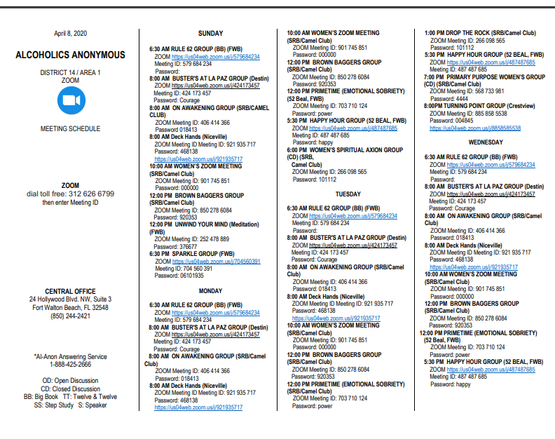

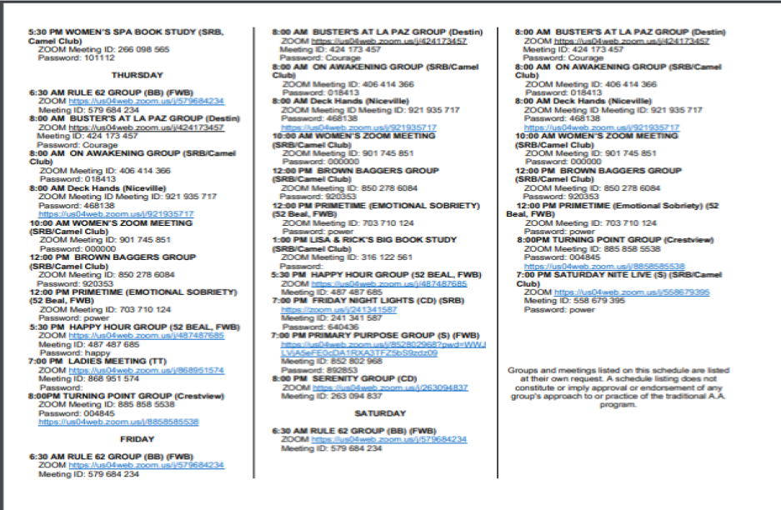

Recovering addicts say coronavirus creates new challenge to stay sober
More than 20 million Americans are battling a substance abuse problem.
By Bill Hutchinson April 2, 2020, 1:15 PM
On a normal Thursday night, 29-year-old Chris Reed and more than 100 recovering alcohol and drug addicts like himself would be filling The Other Side sober bar he opened in northern Illinois to listen to live music, socialize and lean on each other in their daily struggles to keep from relapsing.

But since the coronavirus has swept the globe killing more than 50,000 people, including more than 5,000 in the United States, Reed's sober tavern in Crystal Lake has been shuttered by social distancing rules and all-important physical peer-to-peer meetings for people in recovery have switched to online virtual gatherings.

"I got sober in 2009 from opioid addiction. I just celebrated 10 years in September," Reed told ABC News. "For me, I got sober at 19 and I thought I was the only person who had these issues and then I started going to meetings and I started to see all these other people who had gone through similar things and connecting with them, whether it was just going out to dinner or coffee after a meeting. There was a certain level of camaraderie. That’s just something you can’t produce with the Zoom meetings."

Reed also runs three New Directions sober houses in his community and the Northern Illinois Recovery Center, where in recent days as the virus has spread across the Prairie State he says he's seen an uptick in the number of people new to recovery straining to stay sober.

Stacey Wescott/Chicago Tribune/Tribune News Service via Getty ImagesChris Reed of Crystal Lake, poses for portrait in The Other Side, a sober club that he and his friends are building, in Crystal Lake, Ill., Jan. 13, 2013.Chris Reed of Crystal Lake, poses for portrait in The Other Side, a sober club that he and his friends are building, in Crystal Lake, Ill., Jan. 13, 2013.

"It’s hard enough to make that first decision and say, 'Hey, I’m going to change my life, I’m going to try and get sober.' For all that support to not be as robust and effective as is normally sucks, for lack of a better term," Reed said. "It’s just not the same. There are a lot of struggles."

Dayry Hulkow, a primary therapist at Arete Recovery center, a Delphi Behavioral Health Group facility in Pembroke Pines, Florida, said her organization has seen a significant spike in relapses as stress mounts on people in recovery coping with skyrocketing unemployment and being isolated with family members getting an up close and stark picture of the demons they are battling.

A 2018 national survey on drug use and health by the federal Substance Abuse and Mental Health Services Administration, an arm of the U.S. Department of Health and Human Services, found that 14.8 million Americans, some as young as 12, had alcohol use disorders while another 8.1 million were battling illicit drug use disorders.

Hulkow said she fears the numbers will only get worse as the pandemic grows and puts up roadblocks to recovery services.

"We have already seen relapses happening, moments of crisis, obviously a lot of mental health issues associated with the addiction and all the stresses that are going on in the world," Hulkow told ABC News. "I’m definitely afraid that the numbers are just getting started now."

She said the void of direct access to social support networks, including going to meetings and being in face-to-face contact with supportive friends "is a huge trigger for relapse."

"Also, there is the boredom, having to stay at home with very limited access to the outside world, hobbies meetings and employment. All that kind of stuff, it’s a significant trigger as well," Hulkow said. "Then for those that do have family at home, a lot of times family could ... lead to disputes in the home. Being confined in such a small area without any outside release could also be a trigger for relapse."

Hulkow advised people struggling with recovery to stay in contact with their support groups by phone and to take advantage of virtual meetings offered online.

"Know that there is hope, that this is temporary. This situation is definitely going to pass. We don’t know how or when, but it will pass," Hulkow said.

"The biggest part is trying to maintain a routine as normal as possible," she added. "I know there are many abnormal things about the current situation, but trying to at least stick to our basic routine, which is sleeping times, meal times, self-care time, if there’s exercise, yoga, certain hobbies that we still have access to. Trying to surround yourself with as much positive activities and normalcy within our lives can definitely be very helpful."

In response to the global outbreak, Alcoholics Anonymous chapters worldwide have turned to holding A.A. meetings on video conferencing websites like Zoom and Google Hangouts, or conducting conference calls.

"While we do recognize that for some A.A. members, meeting online may be an adjustment, our experience to share is that from A.A.’s earliest beginning. A.A. membership and recovery has not been contingent upon meeting 'in-person,'" reads a statement from the the General Service of Alcoholics Anonymous, a repository for A.A. members and groups looking for information on meetings and other ways to connect.

"Even prior to this global pandemic, many A.A. members around the world whether homebound, living in remote areas, including Service Members on ships have had meaningful recovery through accessing A.A. literature, letter/email correspondence, phone calls, and online/phone meetings," the statement reads. "Amid coronavirus (COVID-19), though many A.A. members are for the first time, after years of attending in-person meetings are having to learn to adapt to digital platforms, for many alcoholics around the world this is how they have found and maintained recovery in A.A. even before this pandemic."

M.J. Gottlieb, a recovering alcoholic from New York City, said he celebrated his eighth year of sobriety on March 21, one day before Gov. Andrew Cuomo issued a statewide stay-at-home order in an attempt to blunt the spread of the virus -- which as of Thursday had killed more than 2,300 people in the state, including nearly 1,400 in New York City. In November 2018, Gottlieb, an entrepreneur who has owned and operated several clothing brands, launched Loosid, an app providing a platform of hotlines and online or services to break the stigma that sobriety "means the end of fun."

"I had been trying to get sober for many many years and I would invariably find myself at coffee shops and diners. I said to myself, if this is all there is then I’m going to continue to use, which I did for the next 15 years," Gottlieb told ABC News, adding that before the pandemic struck Loosid was introducing people to things like sober travel and restaurants offering sober cocktail or "mocktail" hours.

Since the first week of March, Gottlieb said Loosid has seen a 93.8% increase in monthly active users taking advantage of its online services like mindful meditation and yoga classes.

"There’s about 60,000 people using the platform right now," Gottlieb told ABC News.

He said many people have been using the app's "sober curious" group, where people who suspect they are developing a substance or alcohol abuse problem can find information and seek help. He also said he has seen a 620% increase in dating messages sent.

"I thought this was going to tank, but what I’ve realized is that people are lacking intimacy," Gottlieb said. "People are now reaching out and actually having conversations because they can’t jump out to a restaurant and meet a person right away. So, we’re actually able to give people some level of intimacy to connect with people that they’ll connect with in the future once we are back to the regular speed we were at before COVID."

Back in northern Illinois, Chris Reed said he's been spending hours on the phone with people in recovery and trying to keep those at his sober houses and recovery center stay strong.

"I think the consistent message that we’re giving is, ‘Hey, look at this as an opportunity to focus on yourself because there’s nothing else that you have to do," Reed told ABC News. "You don’t have to be looking for work right now, you don’t have to be doing anything else except for this internal work.”
source: https://abcnews.go.com/Health/lot-struggles-recovering-addicts-coronavirus-creates-challenge-stay/story?id=69914643

We hope everyone is staying safe and SMART during these unprecedented times! Stay close to your AA family and reach out!
-Newsletter by Amanda B
Submit your group’s birthdays for the newsletter at infoandnews@centurylink.net.

