October 2020 AA Newsletter

10th Step: “Continued to take personal inventory and when we were wrong promptly admitted it.”
10th Step Prayer: “God remove the Selfishness, dishonesty, resentment and fear that has cropped up in my life right now. Help me to discuss this with someone immediately and make amends quickly if I have harmed anyone. Help me to cease fight anything and anyone. Show me where I may be helpful to someone else.”
10th Tradition: Alcoholics Anonymous (and Al-Anon) has no opinion on outside issues; hence the A.A. name ought never be drawn into public controversy. ... It does not engage in any controversy, neither endorses nor opposes any cause.
10th Concept: We are of service by accepting responsibility for the authority God has given us and by respecting the authority God has given to others.

AA Birthdays:
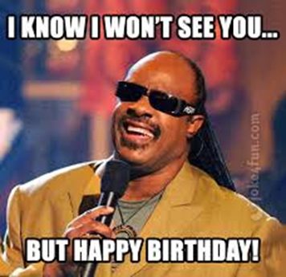
AA Funnies:
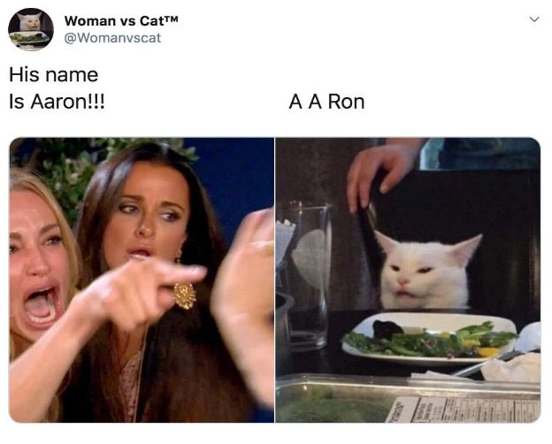

AA Announcements:
Honesty Group Starting “In Person” meeting starting Oct 5th
First Church of Nazarene, 27 First St. SW, FWB 32548

The Weekenders Starting “In Person” meeting starting Sept 27th 5:30pm
Wellness Center, 333 Lewis St., Bldg 3, FWB 32547

**Several meetings are starting to meet in person again so be sure to check website for updated schedule!
Step 10
Daily Checklist
Step Ten: "Continued to take personal inventory and when we were wrong promptly admitted it."
Just for today I will take my own inventory.

 |  | Monday | Tuesday | Wednesday | Thursday | Friday | Saturday | Sunday
Did I lose my temper?

"God grant me the serenity"

Was I self-centered?

"Steps Six, Seven, Eight and Nine"

Did I put others down?

"Acceptance of others"

Did I ask for the help I need from my Higher Power?

"Let Go and Let God"

When I was wrong, did I promptly admit it?

"Courage to change the things I can"

Did I worry or overreact?

"Let Go and Let God"

Did I criticize others?

"Live and Let Live"

Am I disrespectful and did I talk back?
"God grant me the wisdom..."

Did I forget that alcoholism is a family disease which can case unpredictable
behavior?

"God grant me the wisdom to know the difference; Step One"

Did I indulge in self-pity?

"Everyone has problems, together we can make it; Meetings help"

Did I blame anyone else for my actions today?

"How important is it?"

Did I work on any of my defects today?

"Courage to change the things I can"

Was I resentful today?

"Third Step; Keep It Simple"

How am I Doing?
______________________________________________________________________________
With the following: What Program tools are helping me change?
Temper
____________________________________________________________________________________
Resentment
____________________________________________________________________________________
Fear
____________________________________________________________________________________
Criticizing others
____________________________________________________________________________________
Blaming others
____________________________________________________________________________________
Self-pity
____________________________________________________________________________________
Procrastination
____________________________________________________________________________________
Worry
____________________________________________________________________________________
Forgiveness
____________________________________________________________________________________
Talking back
____________________________________________________________________________________
Admitting when I am wrong
____________________________________________________________________________________
Selfishness
____________________________________________________________________________________
Name Calling
____________________________________________________________________________________
Asking my Higher Power for help
____________________________________________________________________________________
Working on one thing at a time
____________________________________________________________________________________
Understanding that alcoholism is a disease
____________________________________________________________________________________
Other things that I am working on changing in myself: ________________________________________
____________________________________________________________________________________
____________________________________________________________________________________
____________________________________________________________________________________

Newsletter By: Amanda B

