March 2020
AA Newsletter:

Step 3: “Made a decision to turn our will and our lives over to the care of God as we understood him.”
Tradition 3: “The only requirement for membership is a desire to stop drinking.”
Concept 3: “To ensure effective leadership, we should endow each element of A.A.--the Conference, the General Service Board and its service corporations, staffs, committees, and executives--with a traditional "Right of Decision."”
3rd Step Prayer: “God, I offer myself to Thee – to build with me and to do with me as Thou wilt. Relieve me of the bondage of self, that I may better do Thy will. Take away my difficulties, that victory over them may bear witness to those I would help of Thy Power, Thy Love, and Thy Way of Life.”

March Birthdays:
On Awakening Group:
Laura E 3-1-15
Sue S 3-16-82
Murphy 3-17-91
Scott G 3-19-12
Nicole P 3-25-14

Upcoming Events:
Quarterly Intergroup Eat & Speak Meeting
March 28th, 2020
Dinner & Fellowship 5:30 pm
Al-Anon Speaker 7pm
AA Speaker 8pm
First Presbyterian Church
134 Beal Pkwy SW
Fort Walton Beach, FL 32548

Area One Convention
“Love & Service”
Sept 11-13th, 2020
Location: Orange Beach Event Center
4672 Wharf Pkwy
Orange Beach, Alabama

Sunshine Convention
10th Annual
“Three pertinent ideas”
May 22-24th, 2020
Defuniak Springs Civic Center
361 North 10th St. Defuniak Springs, FL 32435
Inspirational Quotes:

Inspirational Story:

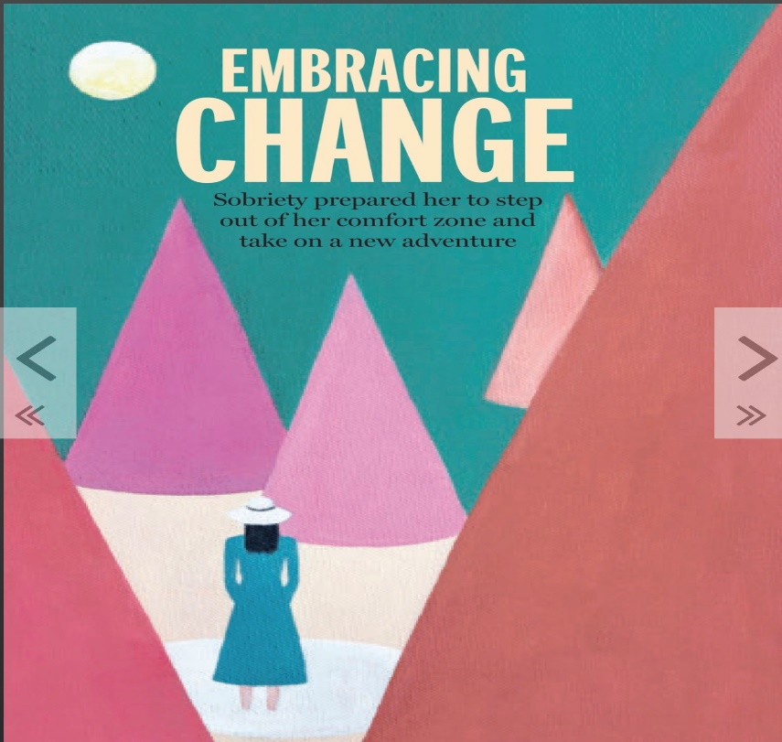
-from the March 2020 edition of the AA Grapevine Magazine
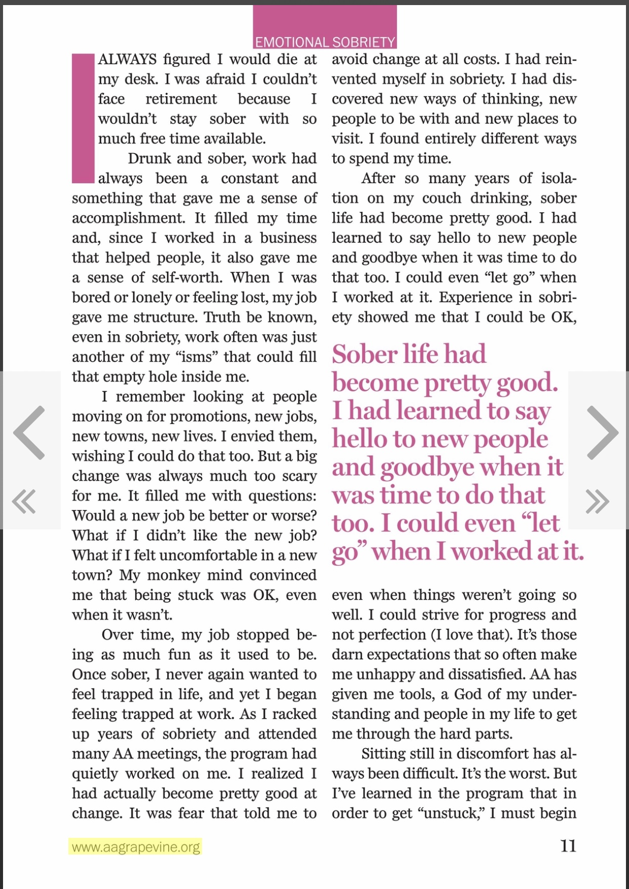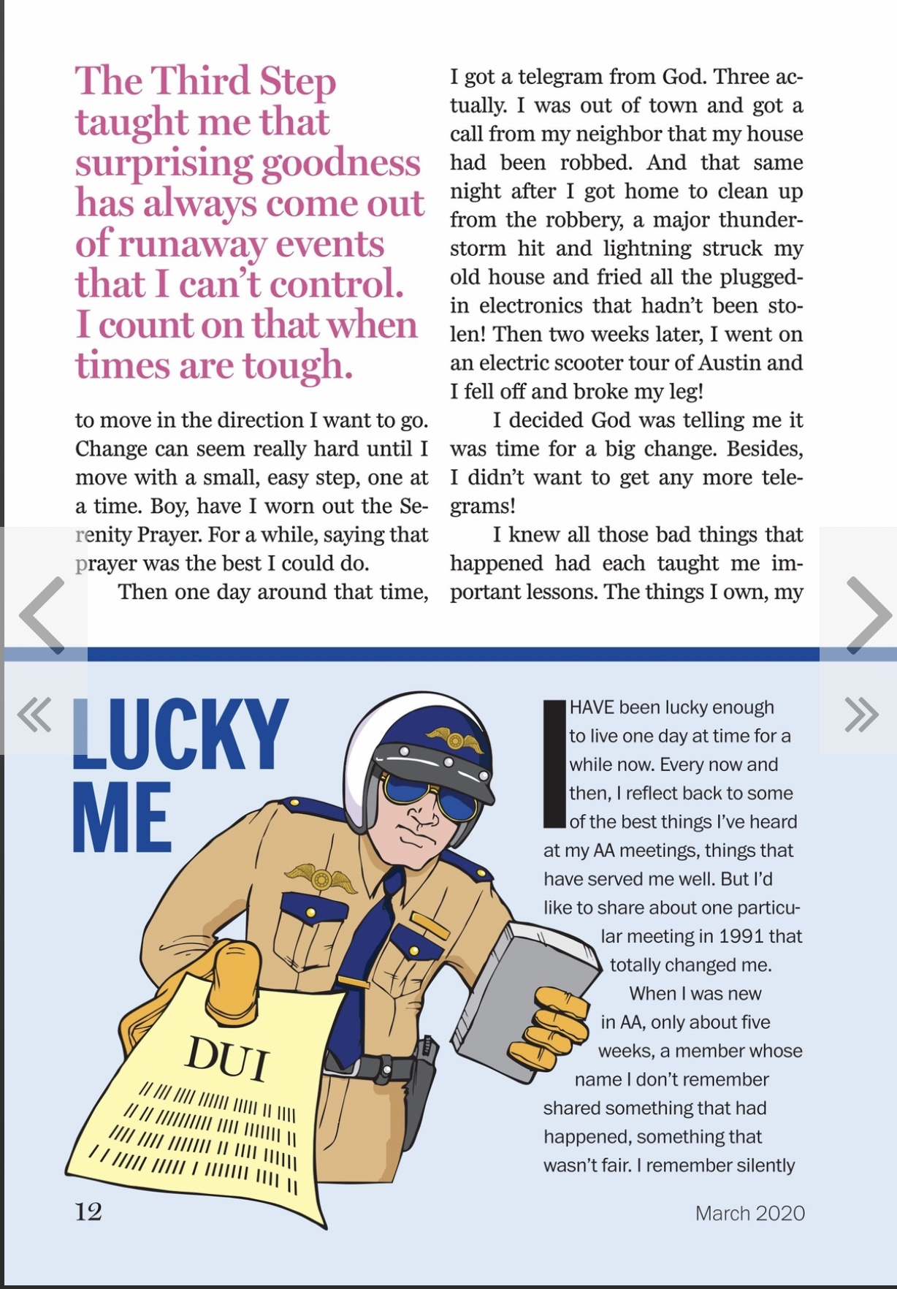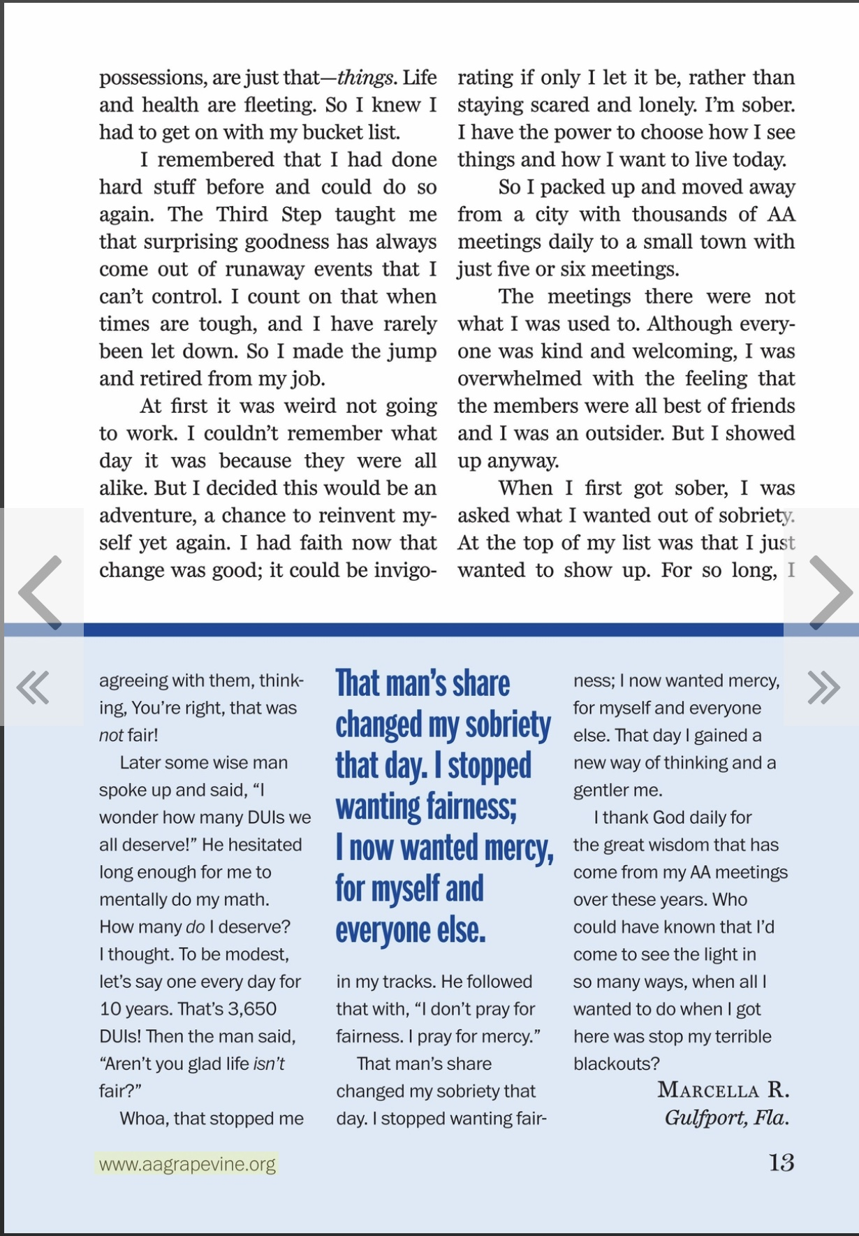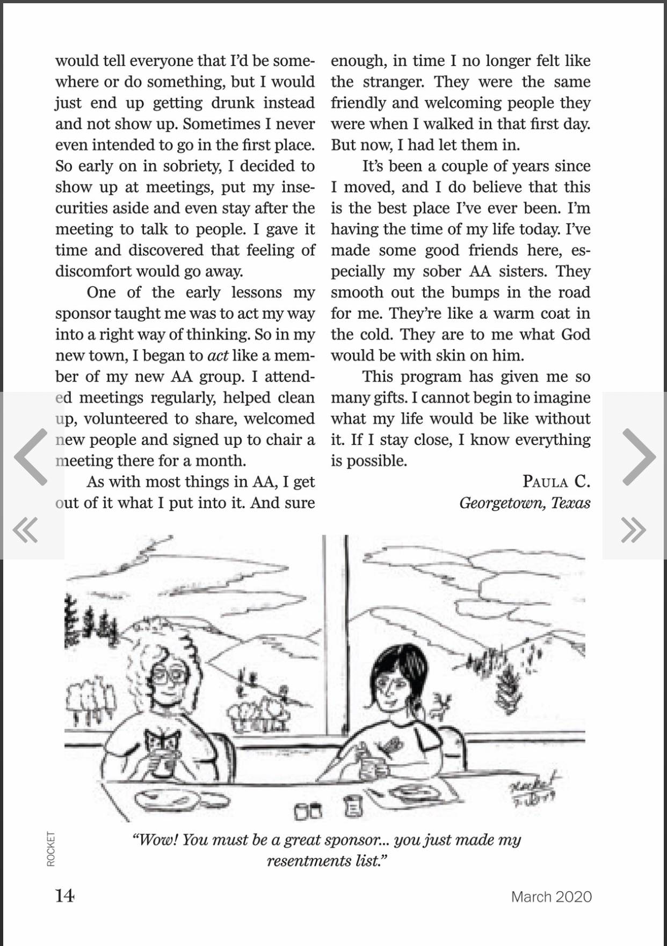
Newsletter by : Amanda B

Inspiring AA Recovery Story:
EARLY SHAKY DAYS
by PJ October 01, 2017 New This Week, Personal Stories 17 2983

What was it that kept me sober in those early shaky days of sobriety? It was in the early 1990’s in Sydney Australia when I found myself sitting in a meeting of Alcoholics Anonymous. I was incredibly frightened, but I was so desperate to change my life that I had no choice but to force myself to walk through those doors. A warm handshake with an assurance from an AA member that I would be all right was the perfect greeting I received when I walked into the meeting room.

I appreciated anonymity (even though I didn’t have an exact idea what it was) when the only personal information an AA member asked for was my first name. At the end of the meeting the same AA member told me, “The first drink does the damage; don’t pick up that first drink one day at a time no matter what happens and come to another meeting.” These two pieces of information saved my life because they simplified how to get sober in AA in a manner that my scrambled brain could understand. Also, even though I did not realize it at the time, I had the third tradition: “The only requirement for membership is an honest desire to stop drinking.” I acted on the advice given to me and have been sober ever since.

I heard some members say that I had to read the Big Book straight away and do the steps immediately or I wouldn’t stay sober. Initially, my mind was like a food blender on full speed, and despite being literate I was unable to read any of the literature. If I tried to read, my focus jumped all over the print, and even if I did manage to make sense of a line, I forget what I read in a matter of seconds. I was worried about this and thought I would never get sober because I couldn’t read the AA literature. Little Davey suggested I put the AA books to one side and come back to them later when my head cleared, which was great advice. I was able to stop putting pressure on myself, essential to achieving quality sobriety. In time, I was able to make a start on reading the AA literature and continue to do so to this day: I just had to be patient.

Little Davey told me how many AA members were unable to read or write, but they got sober. That is one of the reasons why the steps are read out loud at the beginning of the meeting. Little Davey also pointed out that what I needed to be able to understand in AA was “The Language of the Heart.” Scottish Jock from Parramatta used to say, “What keeps me sober might get you drunk.” This allowed me to just be myself and get sober the way that works for me, not anybody else.

I used to worry about my shakes in the meetings and not being able to sit still. I thought I might get thrown out for it, but then I heard Maureen from Edgecliff share about a similar concern she had. A member called Greg the dentist said to her, “Maureen, remember that you are sitting in a room full of ‘professional shakers’ so you just shake away.”

The drinking stories and laughter were so important for me, helping me to identify as an alcoholic in order to accept myself as I was. I realized that AA had an answer for me, that I could get well and lead a happy, sober life if I wanted to.

I would follow certain members around to meetings to hear them share. For example, ‘Railway Norm’ was a regular at the Kogarah Friday lunchtime meeting and I would hang on to every word he said. Railway Norm had been a steam train driver and used to say, “If you were a passenger on my train and knew the condition of the driver up the front, you would want to get off straight away.” He also had the habit of abandoning trains full of passengers in the middle of nowhere so he could get himself a drink, creating chaos on the NSW train system. I can still vividly remember sitting at that meeting of laughter and love and slowly coming to the realization that AA can work for me.

Railway Norm also spoke about the deadly nature of alcoholism. His entry into AA was initiated by his brother, also an alcoholic, who took him to his first meeting in 1950. Norm got sober but, ironically, his brother was still in denial about his own alcoholism. As a doctor, he considered himself to be too intelligent and knowledgeable to be an alcoholic. While Norm accepted his alcoholism and what AA had to offer, his brother refused to have anything to do with AA, hanging himself some years later. This is an all too familiar tragic story we hear in the rooms of AA. The impact of this story on me was profound, bringing sharply into my mind the fact that my life was on the line. I began to take my sobriety very seriously and was determined to do what was necessary to avoid picking up that first drink.

I heard a number of precious one liners at the meetings in the early days. I would hang on to a line I heard at a meeting and it would see me through the day. I was told, “You didn’t get sick overnight, don’t expect to get well overnight.” And Irish Des used to say, “If you don’t get AA, maybe AA will get you,” which is exactly what happened to me.

Jimmy from Ramsgate used to quote Father Tom Dunlea, a Roman Catholic priest, alcoholic, and co-founder of Australian AA. He used to say, “You can never be too stupid to get AA but you can be too clever,” and also to “Keep it simple, take it easy, and make haste slowly.” Father Tom also cautioned us about AA’s survival when he used to say, “AA can never be destroyed from the outside, but it can be destroyed from within.” Father Tom was talking about his own experience of a split between the members in Sydney AA’s ‘Early Shaky Days.’ There were some who believed that American AA would not work for the Australian alcoholic. They broke away from the fledgling AA group, starting their own version of AA. Many of them perished by picking up a drink, while some of the breakaway members did re-join AA and achieved sobriety.

Curly Frank told me “This is the easier softer way.” Terry from Kogarah used to quote Sylvester Minogue, a psychiatrist, alcoholic, and co-founder of Australian AA. He said “If you had a watch that kept perfect time you wouldn’t take it apart to see how it worked. You would just accept that it worked and use it. So, treat the steps the same way, don’t take them apart, just use them as they are.” Terry put it me this way, “If you want what we have, do what we do.” This meant I had to stop analysing the steps and getting stuck in analysis paralysis. Instead I took practical and simple actions to get and stay sober. So, I stayed away from the first drink, went to meetings, got involved, and tried to help where I could. An understanding of the steps came later when I could look back on the changes brought about in my life by doing what Terry and the other old timers did.

In a similar vein, Leo from Newtown used to say “You don’t have to understand the workings of an internal combustion engine in order to drive a motor vehicle. You just need to know how to start the motor, engage drive, accelerate, brake, and steer. In the same way, you don’t have to understand how AA works in order to stay sober, you just need to know what to do.” Metaphorically speaking, I began to drive my sobriety without any need to understand exactly how it all worked. I could see the positive and remarkable changes in my life as proof that what I was doing in AA was working.

Some of the meetings I didn’t like, and I thought there was something wrong with me. I had the impression I had to attend them even though I didn’t like them. I spoke to Jimmy from Ramsgate about this and he just said to me in his matter of fact manner, “Of course you realise that the roof won’t fall in if you don’t come back to this meeting.” I laughed and started to attend meetings where I felt comfortable.

I thought I was the only person who suffered from ungrounded and unfounded fears until I heard Bill from Paddington share. Bill said “My drinking got to a stage where I had to have a drink in order to answer a knock on the front door. Then it progressed to the stage where I had to have a drink in case I had to answer a knock on the front door.” What beautiful words for me to hear from someone who suffered from fears just like I did. I was no longer ‘terminally unique.’

Stan from Ramsgate gave me a tape of the first AA public meeting in the Sydney Town Hall in 1957. One of the speakers on that tape was Sylvester Minogue. Minogue described certain characteristics of the alcoholic. It’s the best ten-minute description of me I have ever heard, and he defines the most outstanding characteristic of the alcoholic as “restlessness,” the inability to be at ease with oneself. He said, “You have to accept yourself as you are, you can’t change yourself. All that AA does is to teach you a philosophy of life, a way of living, that allows you to accept yourself and put up with yourself.” Hearing this description helped me to learn to be myself, and to live more comfortably in my own skin without trying to be perfect.

Over time, AA has opened up for me and I have been able to live my sobriety in practical daily living. I hold onto a quote from Sylvester Minogue on living happily sober, “Forget yourself, help others, and live twenty-four hours at a time.” I’m so grateful for the simple, practical advice given to me in those early shaky days.
About the Author
PJ migrated to Sydney, Australia from Ireland in 1989 and got sober in 1993. Having come from an Irish tradition of oral storytelling he naturally gravitated towards the wonderful Sydney AA storytellers, who shared their experience, strength, and hope. This has proven to be a mainstay of his sobriety, with the tried and tested formula of sharing in a general way what we used to be like, what happened, and what we are like now. He co-founded the Sydney Brookvale Secular ID meeting with Dave in February 2017 and has enjoyed a tremendous boost to sobriety from being part of a new meeting. The Brookvale meeting continues to grow and develop and provides a safe space for those not sure about the “God” bit.
Newletter By: Amanda B.

