February 2021 AA Newsletter:

Step 2: “Came to believe that a Power greater than ourselves could restore us to sanity.”
Tradition 2: “For our group purpose there is but one ultimate authority – a loving God as He may express Himself in our group conscience. Our leaders are but trusted servants, they do not govern.”
Concept 2: “The General Service Conference of A.A. has become, for nearly every practical purpose, the active voice and the effective conscience of our whole Society in its world affairs.”
2nd Step Prayer: “God, I'm standing at the turning point right now. Give me your protection and care as I abandon myself to you and give up my old ways and my old ideas just for today. Amen.”
February Birthdays:
On Awakening Group:
Megan F 2-3-17 Bob M 2-14-19
Nena B 2-6-95 Stacie M 2-27-11
W C G 2-9-16 Sam S 2-22-13
Jim G 2-11-92 Mike K 2-22-16
Tammy W 2-11-15 Glen S 2-19-89
Carolina M 2-13-2017 Sharon H 2-14-05

*submit your group’s birthdays to Amanda@myardor.com to be in that month’s newsletter

-Be sure to check out your local AA website for up to date meeting lists and zoom meeting info!
www.fortwaltonbeachaa.org
-You can also make your 7th tradition contribution on the website if you can’t attend in person meetings due to COVID-19.
Upcoming Events:

FUNNIES!!!
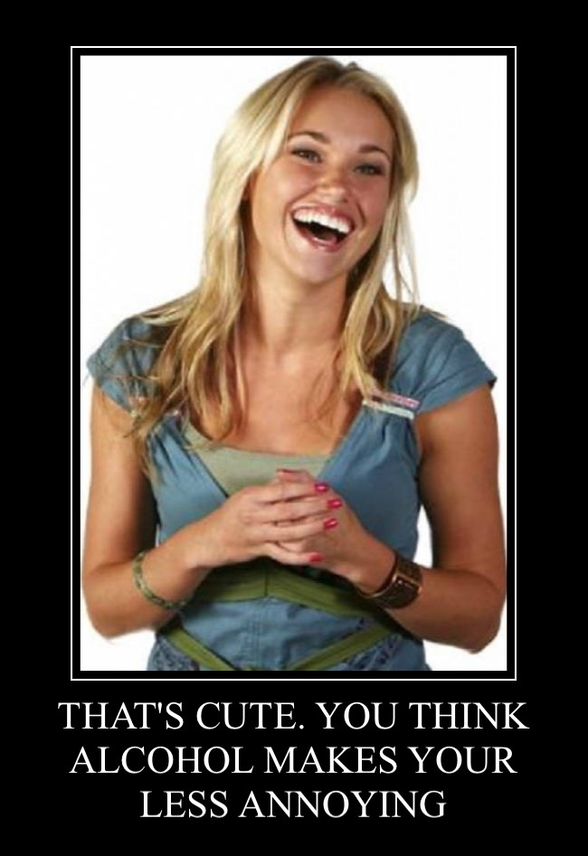

Inspiring AA Recovery Story:
My name is Kimberly M. and I was born in 1989 in New York, but my family moved to the South when I was about two years old. I had a really normal childhood. I have one older brother, and my parents are still together to this day.
I took my first drink at a party when I was 14 years old. I didn’t really like drinking as much as I liked smoking weed. Despite that, I remained active in school; there was nothing truly out of the ordinary during those years.
When I was 16, we got a phone call that changed my family’s life forever. My brother had been on his way home that night and he had been drinking and driving when he got into an accident. He was transported by Life Flight to the hospital. It was devastating for us all. Over the next several months, my family was focused on my brother and his recovery.
When that happened, my parents left me on my own quite a bit, so I start hanging out with my friends more. My friends were little bit older than me and one of the guys was really nice to me. Unfortunately, that guy was also a pretty active drug user. On the weekends, I did a lot of ecstasy, cocaine and Xanax.
Things began to change and I even quit cheerleading after 12 years of active participation. After I graduated from high school, I went to college. I started partying nonstop. I eventually started drinking more than doing drugs.
When I turned 21, I started working for a dentist and I wanted to go to school to become a dental hygienist. So I moved to Florida and began attending college there as well. One of my bosses in Florida basically started my life in prostitution. He told me I was too pretty and too young to let my looks and my body go to waste. (He and I were sleeping together at the time, as well.)
After living a fast life of alcohol, drugs, and sex, I finally called my dad and moved back to my home state. It was September of 2011 and I was super depressed. I didn’t do anything with my time back home. For the following five months, I sat in my bed and I drank. It got so bad that I would wake up at 3 o’clock in the morning to drink.
Obviously, I wasn’t able to get a job (let alone finish school), because I couldn’t function. So, I joined a website and delved back into escorting and prostitution life. I started meeting a lot of guys and making money. At the time, my mind was sick and I didn’t think anything was wrong with it. I was drunk all the time, and I didn’t have feelings.
My schoolwork was horrible and I changed my major four times during the summer of 2012. I met a guy online and he ended up being my sugar-daddy for the next two years. We got into a serious relationship. He got me all my new purses, iPad, MacBook and tons of clothes.
In the summer of 2014, he moved me into a condo he owned. Everything came crashing down after I left home, because I now lived a half-mile from three liquor stores. I didn’t really ever leave the condo and by that time I had flunked all my classes.
In September 2014, I met a guy off (who I will refer to as Jeff) of the Ashley Madison site. I wanted a relationship with somebody that was attractive. (How shallow-minded was I?) He was in the military and legally separated from his wife.
The first time I was hospitalized for drinking was in December of 2014. This guy had no idea I was an alcoholic. He thought I was just really depressed and had mood swings. The doctor told him I was only a few steps from having cirrhosis of the liver.
Immediately after that, I went to Pittsburgh to attend an outpatient program. It didn’t really help me but I participated. Unfortunately, I relapsed two months later. The relapsing continued over the next year. I eventually came clean with Jeff and told him that I still saw other men. After I confessed that to him, I drank and drank, and I woke up to an intervention and was put on a plane to Scottsdale, Arizona the same day. I spent 78 days in Scottsdale before I came home, and again relapsed after only a few months.
Jeff went to Iraq in February of 2015. While he was in Iraq, I was arrested for drinking. He got me into a treatment center in 2016. When I got out of treatment, I went into a sober living home. That was a really big eye-opener for me. The light switch had finally been turned on. I graduated and I completed the whole program.
Today, I have two years of sobriety. I used to continually relapse during Step Nine. I never wanted to make my amends, so I thought it was easier to drink than to start over. Amends were the hardest and best part of my recovery. I am so grateful because I now have a relationship with my family.
I was set to marry Jeff last October, as it was my one-year sobriety date. By that time, my head had become more clear and I realized what I was doing. I felt guilty because he had tried so hard to save me, but he also implied that I would never find another person to love me and that no one else would put up with me. He also implied that nobody else would support my recovery like he did, and so on. I was terrified to break up with him because of what other people might think, but I finally called off the wedding. I broke up with him and gave him the ring back and I’m extremely happy with that choice because I knew it would have ended in divorce.
My life now is amazing. I work for a dentist’s office and like my work. I like to reach out to other young women when I can.
I like to be transparent because I was very secretive in my addiction. I now am able to talk recovery from my heart.
I love my women’s home group! I go to aftercare and I’m also in a drug monitoring company. I check in every day and have to submit my assignments for testing. If I successfully do this for myself, my chances of being sober in five years go up to about 95%. I love my life and am grateful for sobriety, as I would probably not be here now if I were not sober.
Source: https://heroesinrecovery.com/stories/life-in-the-fast-lane/

**submit your inspiring story or a story that has inspired you to amanda@myardor.com

Newsletter By: Amanda B.

