April 2020
AA Newsletter:

Step 4: Made a searching and fearless moral inventory of ourselves.
Tradition 4: Each group should be autonomous except in matters affecting other groups or A.A. as a whole.
Concept 4: “At all responsible levels, we ought to maintain a traditional "Right of Participation," allowing a voting representation in reasonable proportion to the responsibility that each must discharge.”
4th Step Prayer: “Dear God,
It is I who has made my life a mess.
I have done it, but I cannot undo it.
My mistakes are mine &
I will begin a searching & fearless moral inventory.
I will write down my wrongs
But I will also include that which is good.
I pray for the strength to complete the task.”

April Birthdays:
Mossy Head Group
Bill S. 04/09/87 33y

Upcoming Events:

** 2020 AA International Convention in Detroit has been cancelled

Area One Convention
“Love & Service”
Sept 11-13th, 2020
Location: Orange Beach Event Center
4672 Wharf Pkwy
Orange Beach, Alabama

Sunshine Convention
10th Annual
“Three pertinent ideas”
May 22-24th, 2020
Defuniak Springs Civic Center
361 North 10th St. Defuniak Springs, FL 32435

**Individuals should consider donating direct to Intergroup which still maintains the office and phone. You can do so here at: fortwaltonbeachaa.org

Important Info:
~Staying Connected During COVID-19~
A.A. Groups Using Digital Platforms to Find Sobriety During Coronavirus (COVID-19) Outbreak
Virtual Meetings, Email, Phone, Social Media Allow Message of Recovery to Carry On — “ONE DAY AT A TIME”

March 23, 2020
Contact: pressinfo@aa.org

The General Service Office (G.S.O.) of Alcoholics Anonymous for the U.S./Canada functions as a repository for A.A. members and groups who are looking for shared experience from the A.A. Fellowship. As the global situation related to Coronavirus (COVID-19) continues to develop, G.S.O. is fully committed to its role as an important resource center to help navigate this unprecedented public health emergency.

It is important to note, G.S.O. is not an authoritative body over A.A. groups, nor does it initiate rules or directives, as each A.A. group and entity is autonomous and decisions are made through an individual group conscience. Providing guidance on health issues is outside the scope of the A.A. sharing that G.S.O. offers. For anyone experiencing health and safety questions, it is suggested they contact national, state/provincial and local health authorities for appropriate information.

However, in response to the global outbreak, the office does have some general experience regarding how some A.A. groups and members have begun addressing this issue. Many are following ‘’social distancing’’ guidelines established by local, state/provincial and federal officials, while at the same time maintaining their focus on recovery and facilitating digital A.A. meetings.

By attending digital meetings, group members can focus on A.A.’s primary purpose: to carry its message of recovery to the alcoholic who still suffers. Many groups have alerted local A.A. offices or hotlines if they are temporarily not meeting in their regular physical space. Some groups have shared that they are utilizing digital platforms such as Zoom, Google Hangouts, or conducting conference calls.

A.A. groups and members are also creating contact lists, keeping in touch by phone, email or social media. Many local A.A. central/intergroup offices and area service structures have added information to their websites about how to change a meeting format from “in-person” to a digital platform.

A.A. in the digital age has certainly taken on a new meaning in these challenging times, reminding its members and those searching for help that A.A. is not just a “place,” but exists in the hearts, minds and help offered.

For the most up to date meeting information, please visit “A.A. Near You” for local A.A. resources: https://www.aa.org/pages/en_US/find-aa-resources

Anyone who may be seeking help with a drinking problem may visit www.aa.org for information about A.A.

Options for meetings online: https://www.aa.org/pages/en_US/options-for-meeting-online

For information on the A.A. Online Intergroup https://www.aa-intergroup.org/

Understanding Anonymity: https://www.aa.org/pages/en_US/understanding-anonymity

LOCAL Zoom Meeting List:
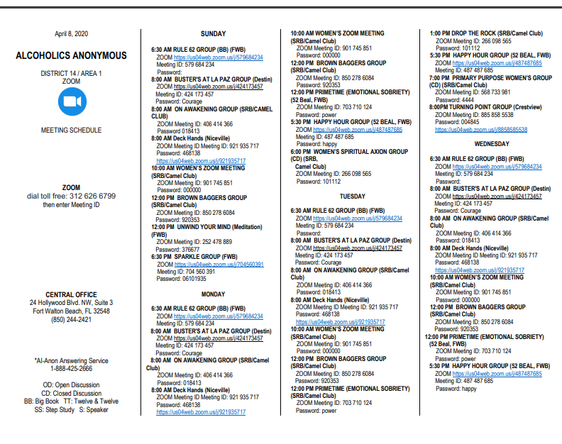

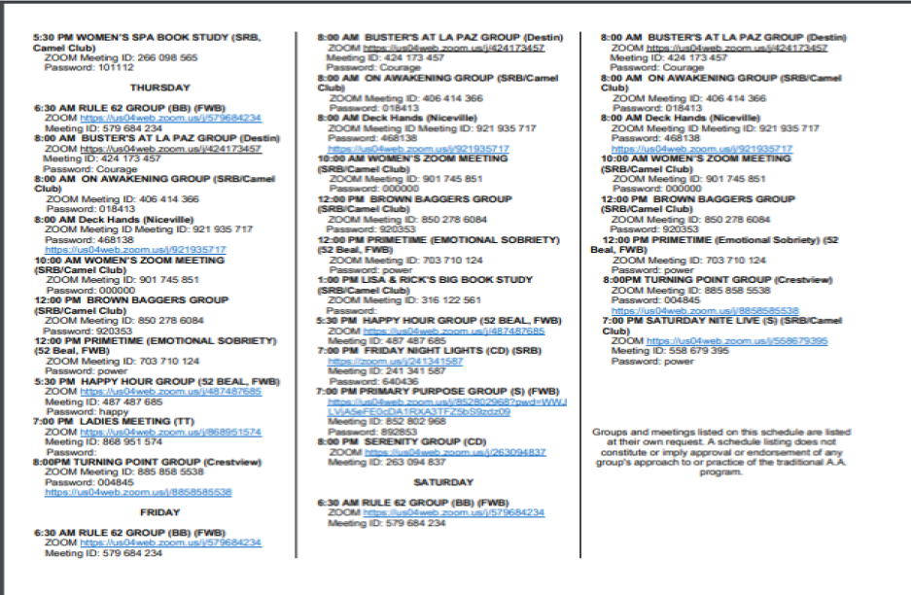

<<< . . . . AA Funny
We hope everyone is staying safe and SMART during these unprecedented times! Stay close to your AA family and reach out!
-Newsletter by Amanda B

